Library Management System

University: SRM IST Ramapuram

Project Title: Library Management System

TechStack used: Java

Student Name: Kirtheka Srinivasan

Reg number: RA2111030020116

**Table of Contents:**

* Introduction
* Objectives
* System Design
* Architecture Diagram
* Implementation
* Technologies Used
* Code Implementation
* Testing
* Test Results
* Conclusion

**Introduction:**

This simple Library Management System project (LMS) is a console-based software that functions to supervise the running of the library by incorporating books, users, and borrowings. This project is devised to help the management and keep track of library resources effortlessly and effectively.

**Objective:**

The main objectives of this project are:

* To develop a user-friendly library management system using Java.
* To implement basic functionalities such as adding books, adding members, and issuing books.
* To create a simple, yet effective, console-based user interface for interacting with the system.

**System Design:**

**Architecture Diagram**

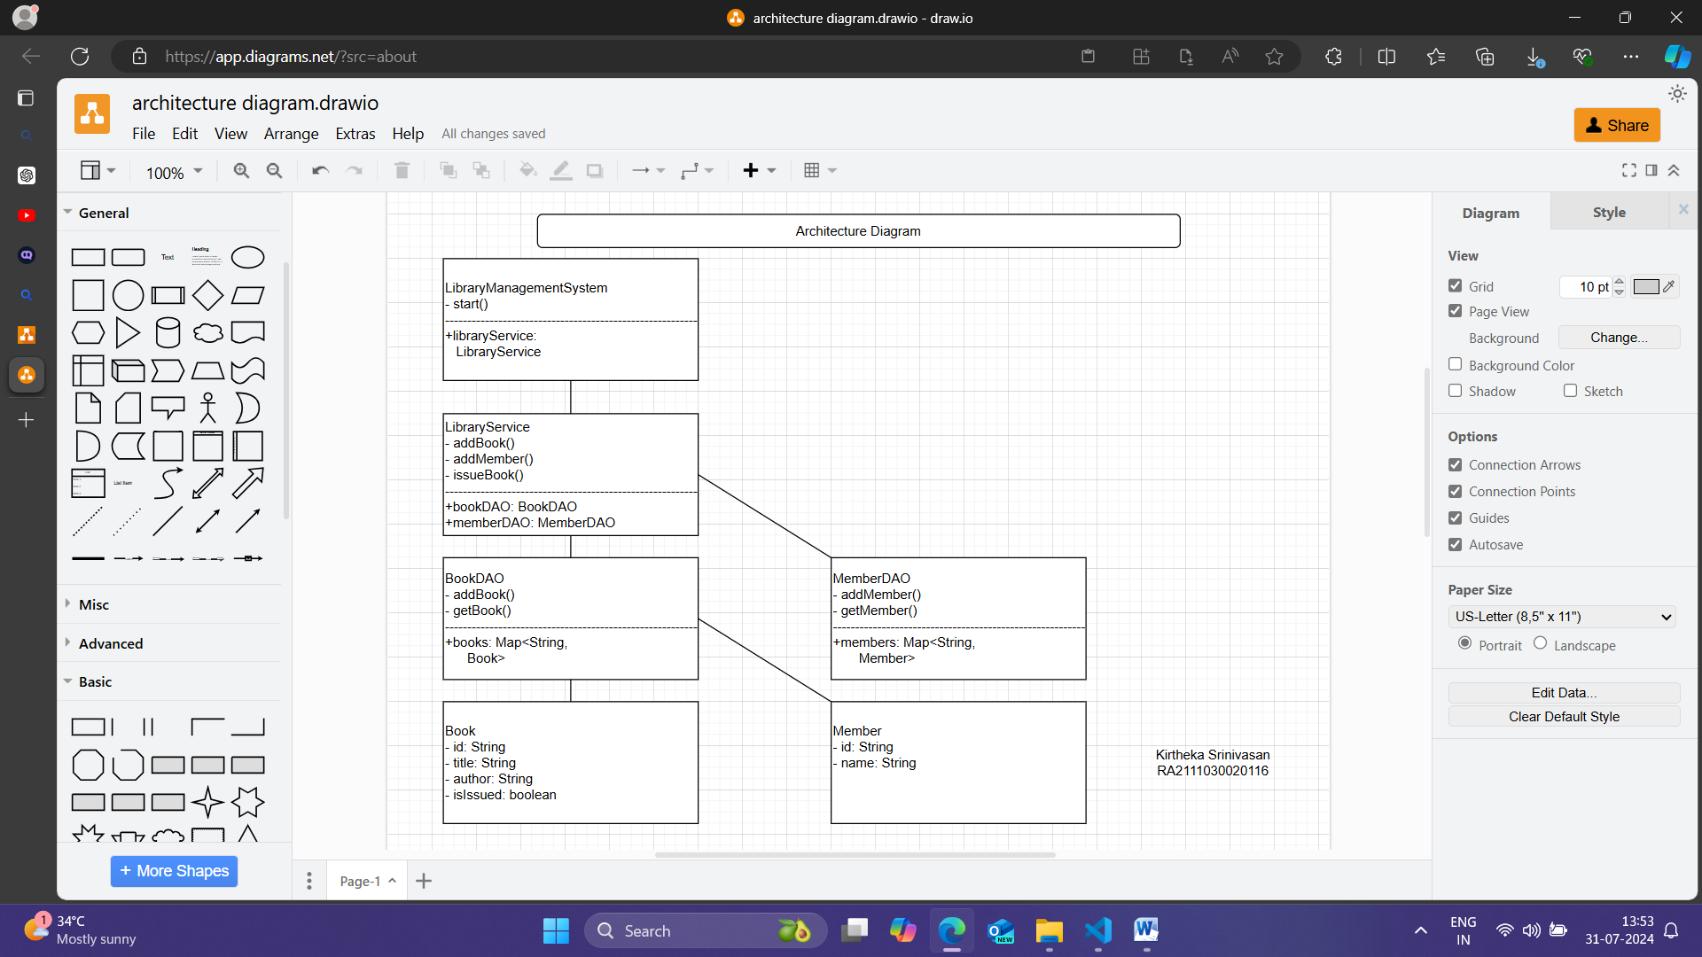

Architecture diagram for this Library Management System project involves overall structure and interaction between different components of the system. For a simple Java-based console application, the key components such as the models, DAOs, service, and user interface.

**Implementation:**

**Technologies Used**

* Programming Language: Java
* Development Environment: Visual Studio Code
* Extensions: Java Extension Pack for Visual Studio Code

**Code Implementation**

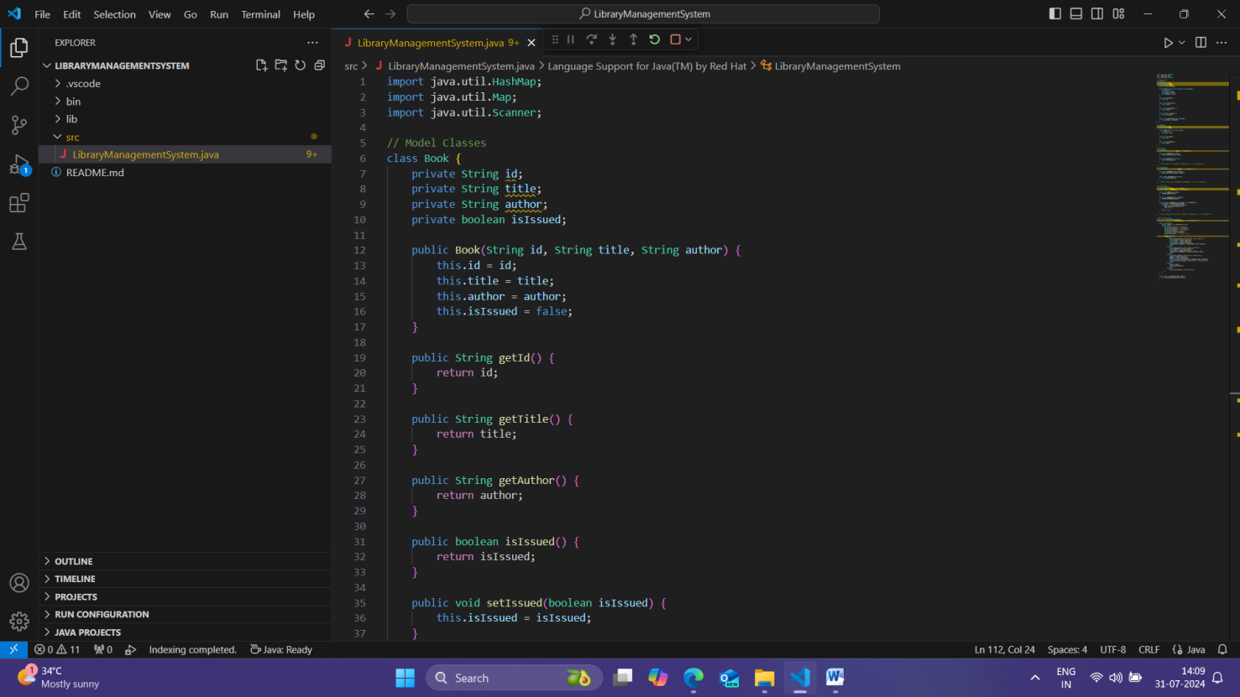

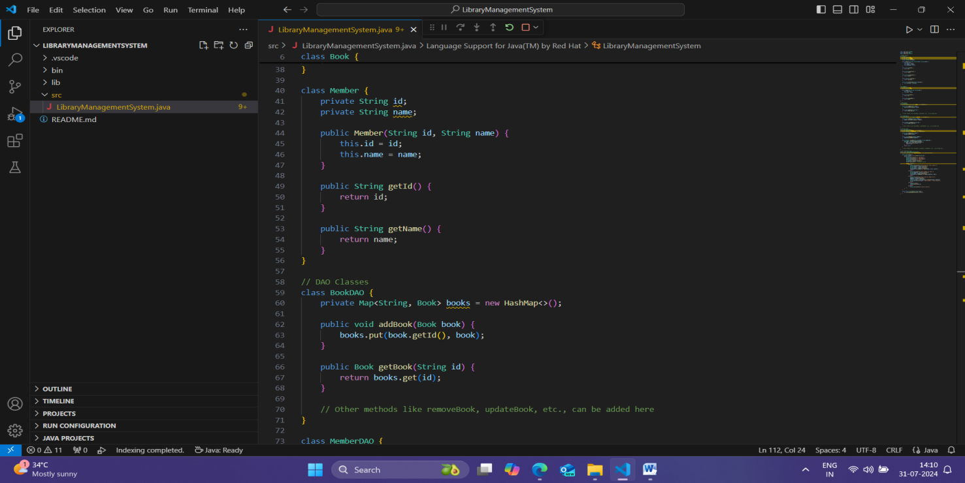

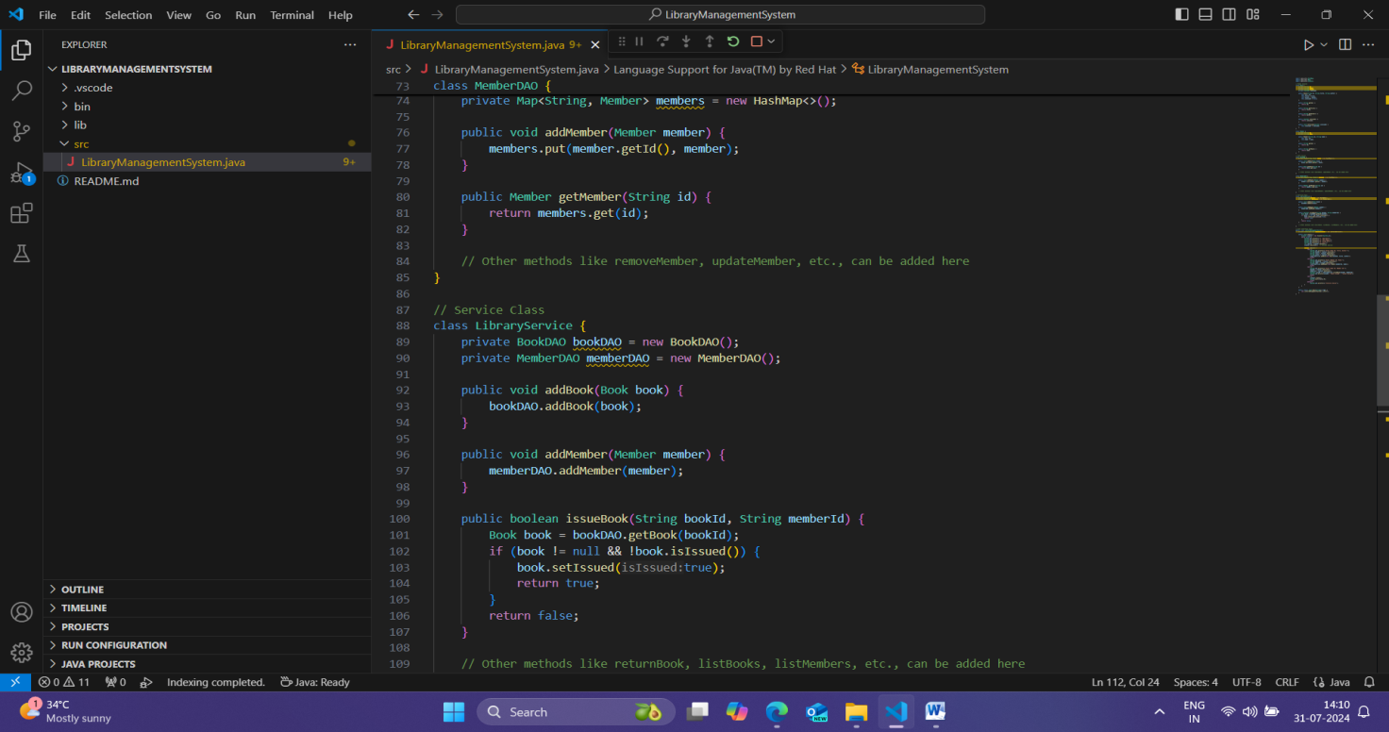

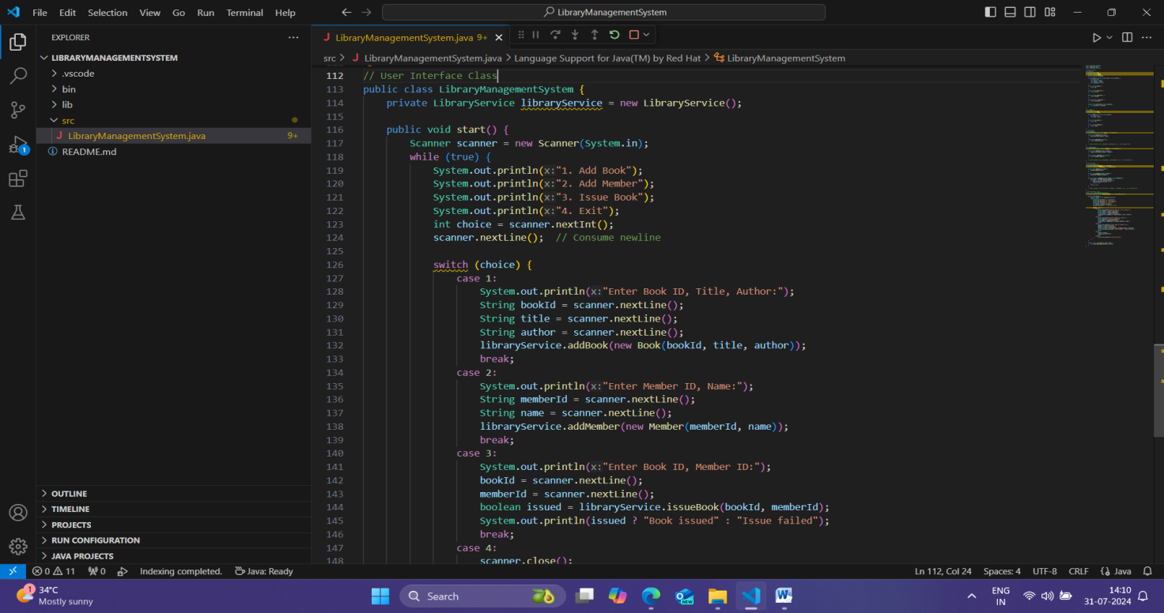

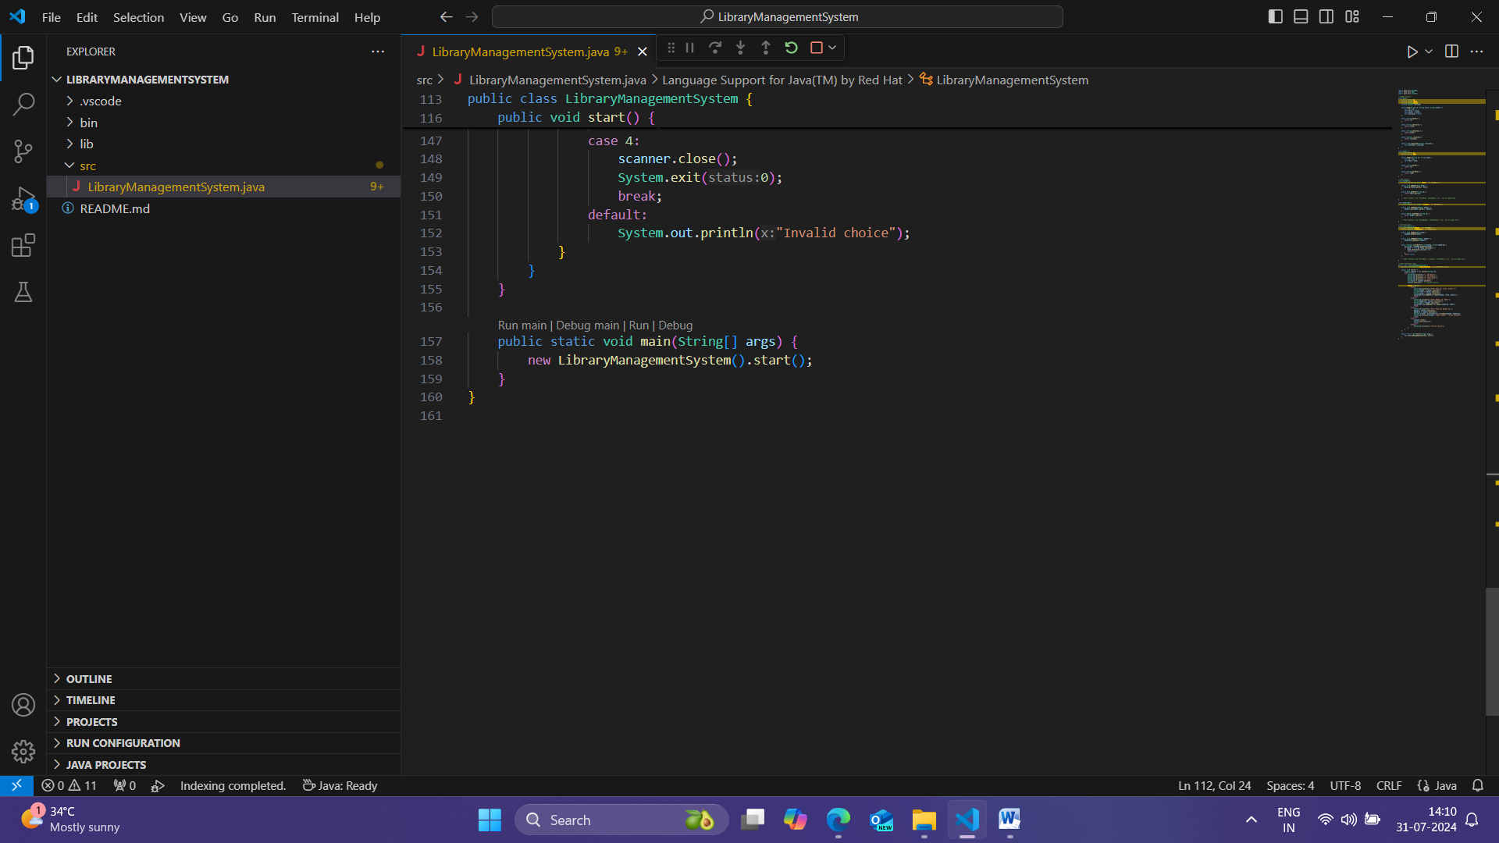

**Testing:**

**Test Results**

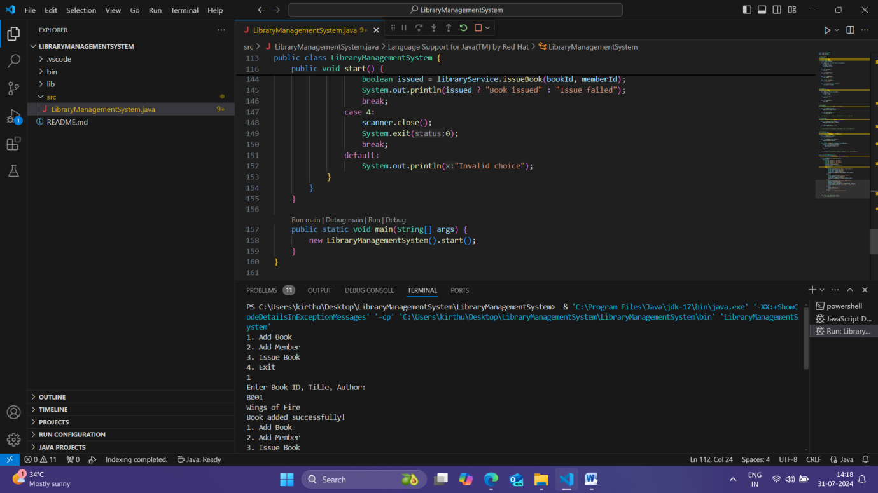

**Conclusion:**

This Library Management System successfully implements basic functionalities such as adding books, adding members, and issuing books. The console-based user interface is simple and user-friendly, making it easy to interact with the system.